**DB Model for GUVI Zen Class**

**Reverse Engineer Diagram:**

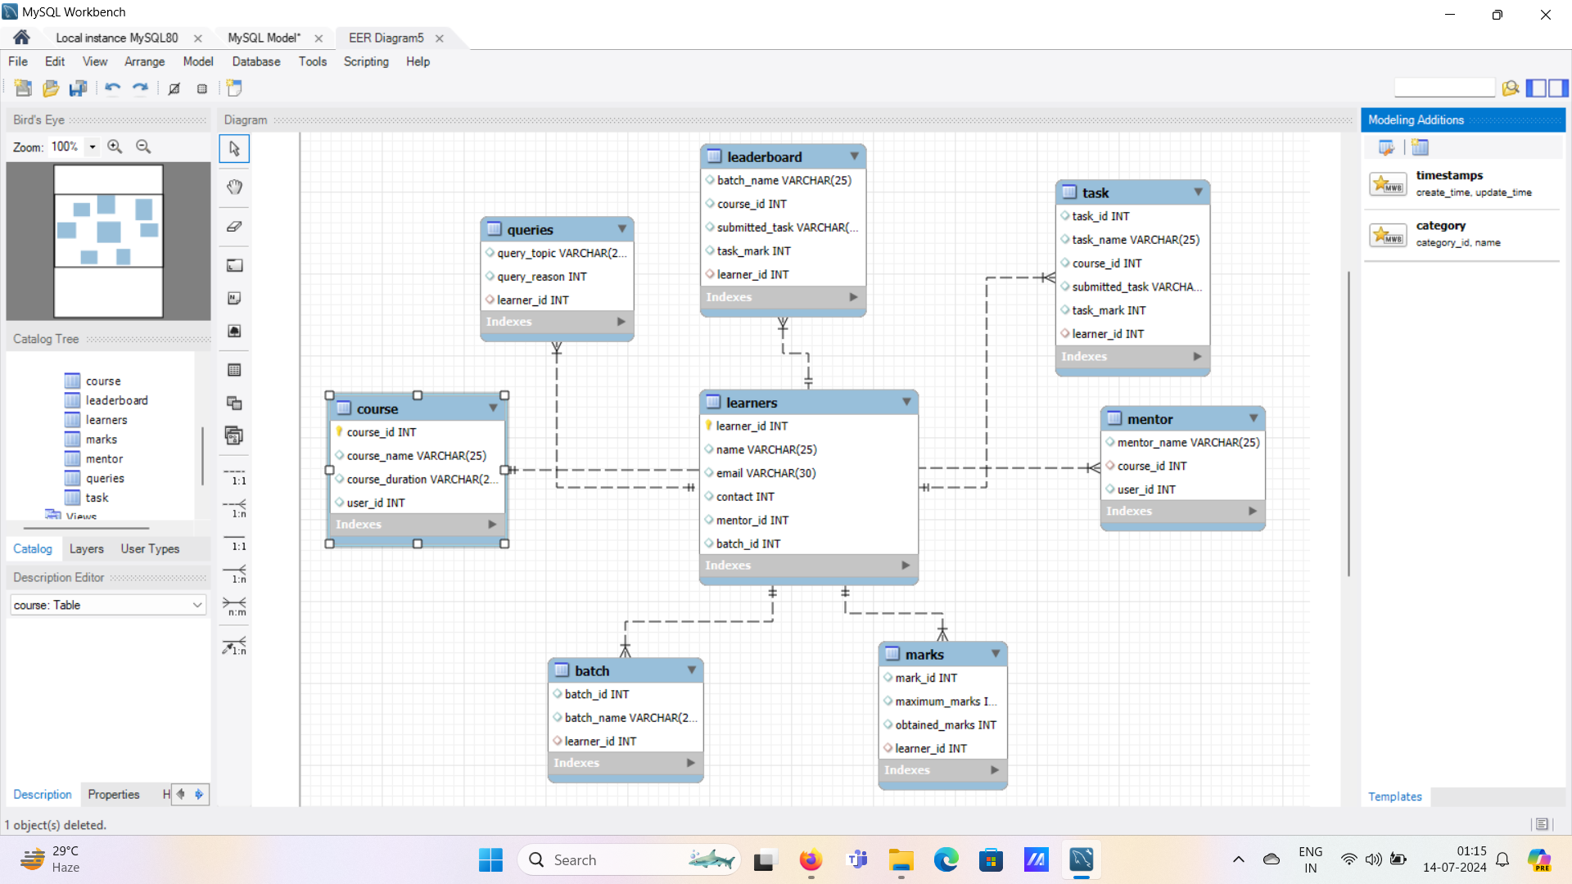

**MySQL Workbench:**

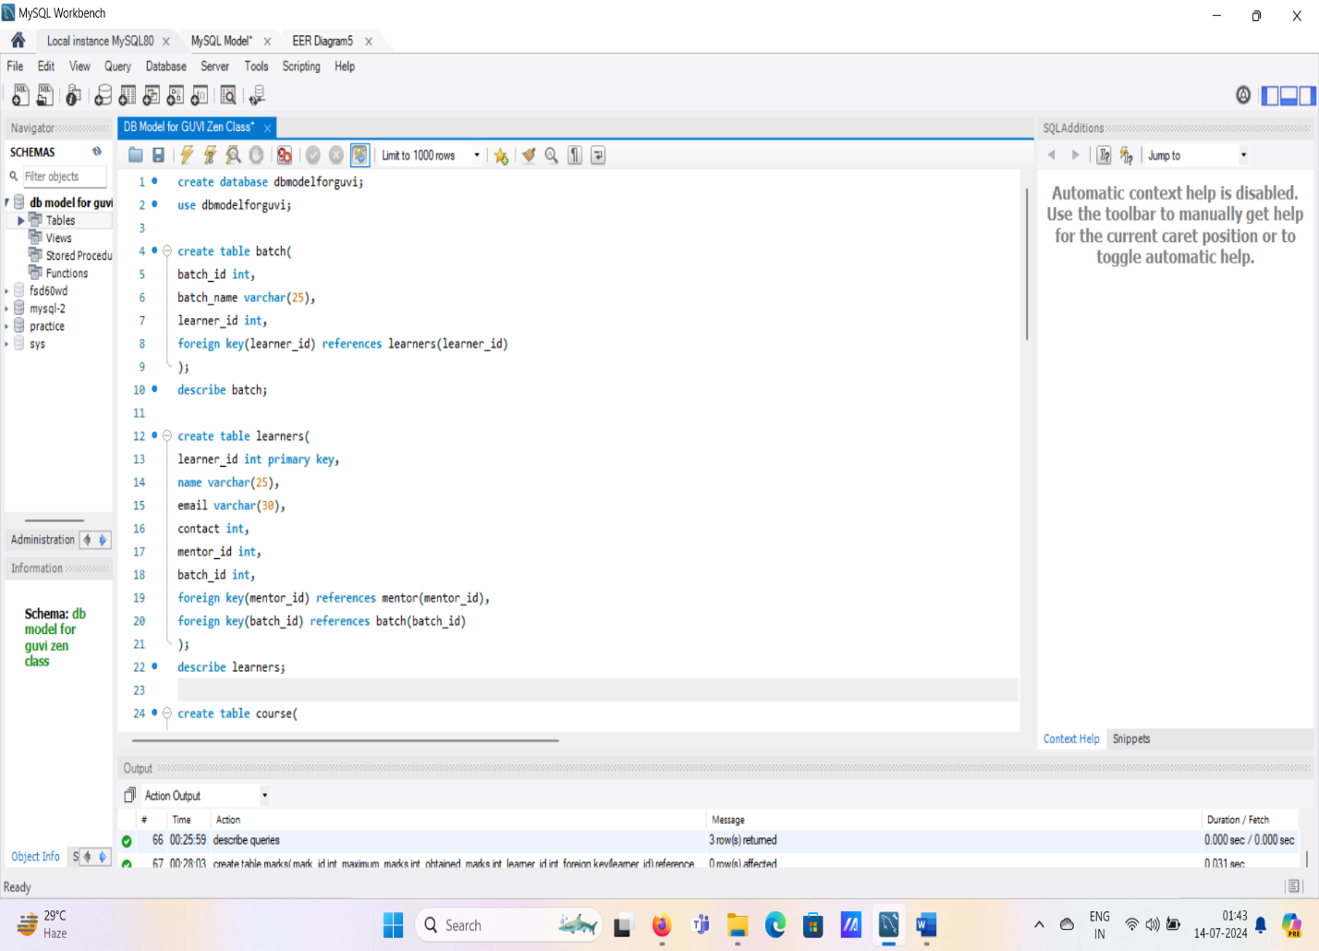

**MySQL Queries:**

create database **dbmodelforguvi**;  
use dbmodelfor**guvi;**

create table batch(

batch_id int,

batch_name varchar(25),

learner_id int,

foreign key(learner_id) references learners(learner_id)

);

describe batch;

create table learners(

learner_id int primary key,

name varchar(25),

email varchar(30),

contact int,

mentor_id int,

batch_id int,

foreign key(mentor_id) references mentor(mentor_id),

foreign key(batch_id) references batch(batch_id)

);

describe learners;

create table course(

course_id int primary key,

course_name varchar (25),

course_duration varchar (25),

learner_id int,

foreign key(learner_id) references learners(learner_id)

);

describe course;

create table mentor(

mentor_id int primary key,

mentor_name varchar (25),

course_id int,

learner_id int,

foreign key(learner_id) references learners(learner_id),

foreign key(course_id) references course(course_id)

);

describe mentor;

create table task(

task_id int,

task_name varchar(25),

course_id int,

submitted_task varchar(25),

task_marks int,

learner_id int,

foreign key(learner_id) references learners(learner_id)

);

describe task;

create table leaderboard(

batch_name varchar(25),

course_id int,

submitted_task varchar(25),

task_mark int,

learner_id int,

foreign key(learner_id) references learners(learner_id),

foreign key(course_id) references course(course_id),

foreign key(task_mark) references task(task_mark)

);

describe leaderboard;

create table queries(

query_topic varchar(25),

query_reason varchar(25),

learner_id int,

foreign key(learner_id) references learners(learner_id)

);

describe queries;

create table marks(

mark_id int,

maximum_marks int,

obtained_marks int,

learner_id int,

foreign key(learner_id) references learners(learner_id)

);

describe marks;